Permit Code Changes, annotated.
https://library.municode.com/TN/Memphis/codes/code_of_ordinances?nodeId=TIT12STSIPUPL_CH12-52PAPUAS
Tuesday Council resolution, http://memphistn.gov/Portals/0/pdf_forms/CouncilDocuments-1-112117.pdf see page 38.
This is the current permit code annotated with the changes that are in the Council document. Insertions are in red, deletions are in red and stricken-through , and changes have a deletion and an insertion both.
Some large changes and insertions have a copy of the new proposal framed in red. Occasional comments are in the right margin and have pink highlighting.
We did this by starting with the current statute and making the changes required to produce the amended document. It was not produced from the Word doc created by the city as a draft.
CHAPTER 12-52. - PARADES AND PUBLIC ASSEMBLIES
Sections:

Sec. 12-52-1. - Definitions.
As used in this chapter:
City is the City of Memphis, Tennessee.
Director of police is the director of the police services division of the city or his or her designee.
Parade or Races is are any march, demonstration, procession or motorcade consisting of persons, animals, or vehicles or a combination thereof upon the streets, parks or other public grounds within the city with an intent of or the effect of attracting public attention that and interferes with or has a tendency to interfere with the normal flow or regulation of traffic upon the streets, parks or other public grounds. Parade does not include a private motorcade of vehicles transporting persons within the city limits from one destination to another destination with no intent to attract public attention or interfere with the normal flow or regulation of traffic upon the public streets.
Parade/race or public assembly permit is a permit as required by this chapter for parades or races.
Permit office is the office or department responsible for the issuance of any and all permits required under this chapter.
Person is any person, firm, partnership, association, corporation, company or organization of any kind.
Public assembly is any meeting, demonstration, picket line, rally or gathering of more than 25 persons for a common purpose as a result of prior planning that interferes with or has a tendency to interfere with the normal flow or regulation of pedestrian or vehicular traffic or occupies any public area in a place open to the general public, to the hindrance of others, not including those spaces duly rented from an appropriate agency, including but not limited to a public park pavilion.
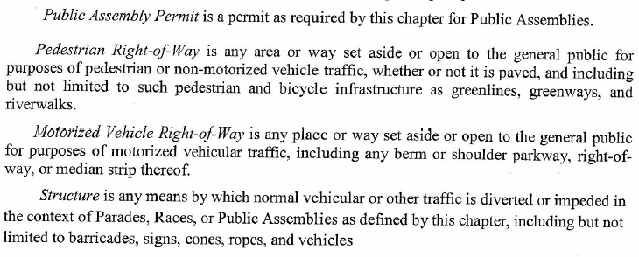
Sidewalk is any area or way set aside or open to the general public for purposes of pedestrian traffic, whether or not it is paved.
Street is any place or way set aside or open to the general public for purposes of vehicular traffic, including any berm or shoulder parkway, right-of-way, or median strip thereof.

(Code 1985, § 21-28(a); Ord. No. 4576, § 1, 4-21-1998; Ord. No. 4875, §§ 1, 2, 6-19-2001)

Sec. 12-52-2. - Permit required.
No person shall engage in or conduct any parade or public assembly unless a permit is issued by the permit office after consultation with the director of police.
(Code 1985, § 21-28(b); Ord. No. 4576, § 1, 4-21-1998; Ord. No. 4875, §§ 1, 2, 6-19-2001)
Sec. 12-52-3. - Exceptions.
This chapter shall not apply to the following:
- Funeral processions/proceeding by vehicle under the most reasonable route from the funeral home, church or residence of the deceased to the place of interment;
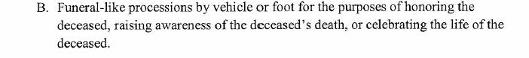

B. C. Students going to or from school classes or participating in educational activities, provided that such conduct is under the immediate direction and supervision of the proper school authorities;
C. D A governmental agency acting within the scope of its functions;
D. E Spontaneous events occasioned by news or affairs coming into public knowledge within three seven (7) days of such public assembly, provided that the organizer thereof gives written notice to the city at least 24 hours prior to such parade or public assembly; and
E. F Private gatherings, affairs or activities on private property that may inadvertently interfere with the normal flow or regulation of traffic upon the public streets.
(Code 1985, § 21-28(c); Ord. No. 4576, § 1, 4-21-1998; Ord. No. 4875, §§ 1, 2, 6-19-2001)
Sec. 12-52-4. - Application for permit.
A. A person seeking a parade/Race or public assembly permit shall file an application with the city permit office on forms provided by such officer and the application shall be signed by the applicant under oath.
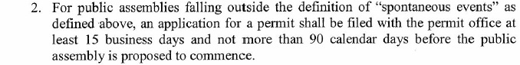
B. 1. For parades or public assemblies races, an application for a permit shall be filed with the permit office at least 14 business 90 calendar days and not more than 180 days before the parade or public assembly is proposed to commence. The director of police may waive the minimum 14 business 90 calendar day filing period and accept an application filed within a shorter period if, after due consideration of the date, time, place and nature of the parade or public assembly race, the anticipated number of participants, and the city services required in connection with the event, the director of police determines that the waiver will not present a hazard to public safety, health and welfare.
C. The application for a parade or public assembly permit shall set forth the following information, as pertinent:
1. The name, address and telephone number of the person, group of persons, firm, partnership, association, company or organization seeking to conduct such parade or public assembly;
2. The names, addresses and telephone numbers of the headquarters of the organization for which the parade or public assembly is to be conducted, if any, and the authorized and responsible heads of the organization;
3. The requested date of the parade or public assembly event;
4. The Any route to be traveled, including the starting point and the termination point;

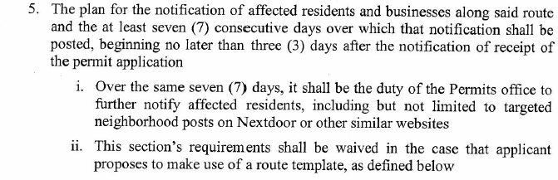
56 The approximate number of persons who, and animals and vehicles which, will constitute such parade or public assembly and the type of animals and description of the vehicles;
67. The hours when such parade or public assembly event will start and terminate;
78. A statement as to whether the parade or public assembly will occupy all or only a portion of the width of the streets proposed to be traversed; If the event is proposed to occupy an entire rather than a portion of a pedestrian or vehicular right-of-way, a statement justifying such use.
89. The location by street of any assembly areas for such parade or public assembly event;
910. The time at which units of the parade or public assembly event will begin to assemble at any such area;
110. The intervals of space to be maintained between units of such parade or public assembly event;
121. If the parade or public assembly event is designed to be held by, or on behalf of, any person other than the applicant, the applicant for such permit shall file a letter from that person with the permit office authorizing the applicant to apply for a permit on his or her behalf;
132. The type of public assembly event, including a description of activities planned during the event;
143. A description of any recording equipment, sound amplification equipment, banners, signs or other attention-getting devices to be used in connection with the parade or public assembly event;
154. The approximate number of participants (spectators are by definition not participants);
165. The approximate number of spectators;
176. A designation of any public facilities or equipment to be utilized; and
187. Any additional information that either the permit office or director of police finds reasonably necessary to make a fair determination as to whether a permit should be issued.
(Code 1985, § 21-28(d); Ord. No. 4576, § 1, 4-21-1998; Ord. No. 4875, §§ 1, 2, 6-19-2001)
Sec. 12-52-5. - Fees.
A nonrefundable fee of $25.00 _____ to cover administrative costs of processing the permit shall be paid to the city by the applicant when the application is filed, except in cases where the parade or public assembly will require the closing of public streets or diversion of the normal flow of pedestrian or vehicular traffic with barricades, a nonrefundable fee of $50.00 100 shall be paid when the application is filed.
(Code 1985, § 21-28(e); Ord. No. 4576, § 1, 4-21-1998; Ord. No. 4875, §§ 1, 2, 6-19-2001)
Sec. 12-52-6. - Police protection.
A. The director of police shall determine whether and to what extent a parade or public assembly will reasonably require additional police protection to control traffic and preserve public safety.
B. The director of police shall base his decision on the types of public safety measures required for the proposed parade or public assembly on the size, location, duration, time and date of the event, the number of streets and intersections blocked or affected by the event, the need to detour or preempt citizen travel and use of the streets and sidewalks and realistic concerns and threats of social disorder, personal injuries, property damage and individual rights violations arising from the event. The speech content of the event shall not be a factor in determining the amount of police protection necessary, unless past experiences with similar events have demonstrated a need for additional police protection to protect event participants, spectators, passers-by and law enforcement personnel, and to preserve free speech and assembly rights of event sponsors and participants.
C. The director of police shall determine if it is possible, without disrupting ordinary police services or compromising public safety, for regularly scheduled on-duty personnel to police the event. If additional police protection for the parade or public assembly is deemed necessary by the director of police, he or she shall so inform the applicant for the permit. The applicant then shall have the duty to secure the police protection deemed necessary by the director of police at the sole expense of the applicant. The director of police shall have the authority to enter into agreements with any applicant for additional police protection including security for the costs thereof.
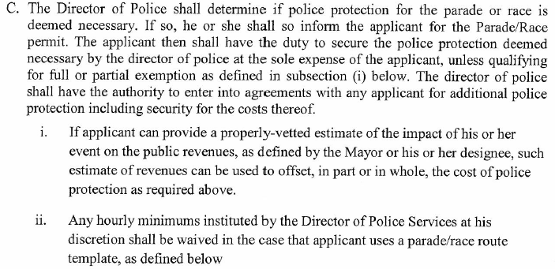
D. The director of police shall be fully authorized to implement and require reasonable steps to forestall potential disorder and civil hostilities among participants, observers and opponents of a proposed event, including but not limited to: zoning of areas in proximity of the event site, crowd control measures, metal detector searches of all entrants to the event site, traffic rerouting, cessation of street parking, and use of undercover officers. Any such measures shall be narrowly tailored to advance the city's interest in public safety and protection of the rights to free speech and assembly.
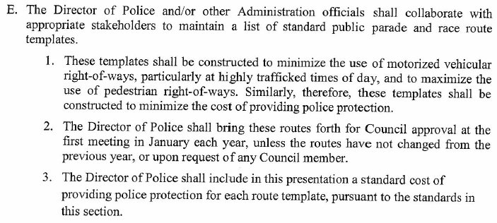
(Code 1985, § 21-28(f); Ord. No. 4576, § 1, 4-21-1998; Ord. No. 4875, §§ 1, 2, 6-19-2001; Ord. No. 5502, § 1, 3-19-2013)
Sec. 12-52-7. - Standards for issuance.
A. The permit office, after consultation with the director of police, shall approve or deny, by five business days, a permit as provided for herein when, from a consideration of application and from such other information as may otherwise be obtained, it finds that:
1. The conduct of the parade or public assembly will not substantially interrupt the safe and orderly movement of other pedestrian or vehicular traffic contiguous to its route or location;
2. The conduct of the parade or public assembly will not require the diversion of so great a number of city police officers to properly police the line of movement and the areas contiguous thereto as to prevent normal police protection of the city;
3. The concentration of persons, animals, and vehicles at public assembly points of the parade or public assembly will not unduly interfere with proper fire and police protection of, or ambulance service to, areas contiguous to such public assembly areas;
4. The conduct of the parade or public assembly is not reasonably likely to cause injury to persons or property;
5. The parade or public assembly is scheduled to move from its point of origin to its point of termination expeditiously and without unreasonable delays en route;
6. Adequate sanitation and other required health facilities are or will be made available in or adjacent to any public assembly areas;
7. There are sufficient parking places near the site of the parade or public assembly to accommodate the number of vehicles reasonably expected;
8. The applicant has secured the police protection, if any, required under section 12-52-6;
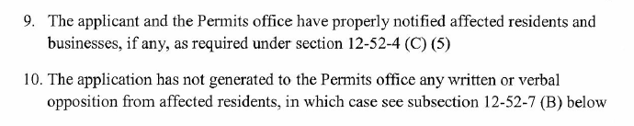

119. Such parade or public assembly is not for the primary purpose of advertising any product, goods or event that is primarily for private profit, and the parade itself is not primarily for profit. The prohibition against advertising any product, goods or event shall not apply to signs identifying organizations or sponsors furnishing or sponsoring exhibits or structures used in the parade;
120. No parade or public assembly permit application for the same time and location is already granted or has been received and will be granted;
131. No parade or public assembly permit application for the same time but not location is already granted or has been received and will be granted, and the police resources required for that prior parade or public assembly are so great that in combination with the subsequent proposed application, the resulting deployment of police services would have an immediate and adverse effect upon the welfare and safety of persons and property; and
142. No event is scheduled elsewhere in the city where the police resources required for that event are so great that the deployment of police services for the proposed parade or public assembly would have an immediate and adverse effect upon the welfare and safety of persons and property.
B. No permit shall be granted that allows for the erection or placement of any structure, whether permanent or temporary, on a city street, sidewalk or right-of-way unless advance approval for the erection or placement of the structure is obtained from the city council.

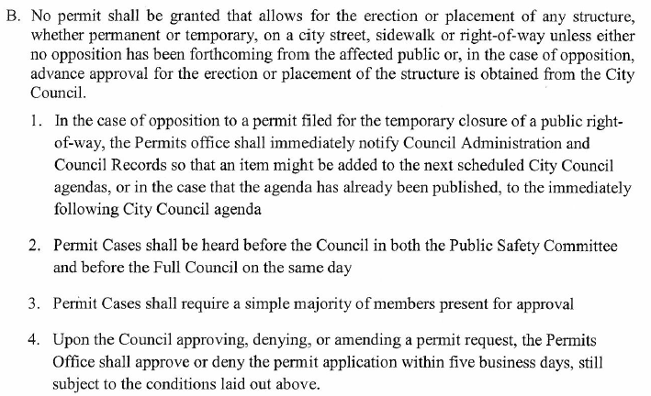

(Code 1985, § 21-28(g); Ord. No. 4576, § 1, 4-21-1998; Ord. No. 4875, §§ 1, 2, 6-19-2001)
Sec. 12-52-8. - Nondiscrimination.
The permit office, after consultation with the director of police, shall uniformly consider each application upon its merits and shall not discriminate in granting or denying permits under this chapter based upon political, religious, ethnic, race, disability, sexual orientation or gender-related grounds.
(Code 1985, § 21-28(h); Ord. No. 4576, § 1, 4-21-1998; Ord. No. 4875, §§ 1, 2, 6-19-2001)
Sec. 12-52-9. - Notice of denial of application.
The permit office shall act promptly upon a timely filed application for a parade or public assembly permit, but in no event shall grant or deny a permit less than 48 hours prior to the event. If the permit office, after consultation with the director of police, disapproves the application, it shall notify the applicant either by telephone, facsimile, personal delivery or certified mail at least 48 hours prior to the event of his or her action and state the reasons for denial. The permit office shall develop procedures for the documentation of the proof of delivery and receipt of denial.
(Code 1985, § 21-28(i); Ord. No. 4576, § 1, 4-21-1998; Ord. No. 4875, §§ 1, 2, 6-19-2001)
Sec. 12-52-10. - Alternative permit.
A. The permit office, after consultation with the director of police, in denying an application for a parade or public assembly permit, may authorize the conduct of the parade or public assembly event at a date, time, location or route different from that named by the applicant. An applicant desiring to accept an alternate permit shall, within 24 hours after notice of the action of the permit office, file a written notice of acceptance with the permit office.
B. An alternate parade or public assembly permit shall conform to the requirements of, and shall have the effect of, a parade or public assembly permit issued under this chapter.
(Code 1985, § 21-28(j); Ord. No. 4576, § 1, 4-21-1998; Ord. No. 4875, §§ 1, 2, 6-19-2001)
Sec. 12-52-11. - Appeal procedure.
A. Any applicant shall have the right to appeal the denial of a parade or public assembly permit to the city council. The denied applicant shall make the appeal within five days after receipt of the denial by filing a written notice with the permit office and a copy of the notice with the city comptroller. The city council shall act upon the appeal at the next scheduled meeting following receipt of the notice of appeal, unless the agenda for said meeting has already been published, in which the Council shall act upon the appeal at the meeting following the next scheduled meeting.
B. In the event that the city council rejects an applicant's appeal, the applicant may file an immediate request for review with a court of competent jurisdiction.
(Code 1985, § 21-28(k); Ord. No. 4576, § 1, 4-21-1998; Ord. No. 4875, §§ 1, 2, 6-19-2001)
Sec. 12-52-12. - Notice to city and other officials.
Immediately upon the issuance of a parade or public assembly permit, the permit office shall send a copy thereof to the following additional persons, whom shall have the duty to validate that no undue impacts on other City services shall occur, or, in the case of impacts being ancillary and reasonable, those services are prepared.:
A. The mayor;
AB. The city attorney;
C. The police director;
BD. The fire director; The Director of Fire services
E. The director of the department of public works;
F. The postmaster;
G. The manager or responsible head of each public transportation utility, the regular routes of whose vehicles will be affected by the route of the proposed parade or public assembly; and
H. The city council chairperson.
C: The City Engineer
D: The CEO of MATA
(Code 1985, § 21-28(l); Ord. No. 4576, § 1, 4-21-1998; Ord. No. 4875, §§ 1, 2, 6-19-2001)
Sec. 12-52-13. - Contents of permit.
Each parade or public assembly permit shall state the following information:
A. Starting and approximate ending time;
B. Minimum speed of parade/race units;
C. Maximum speed of parade/race units;
D. Maximum interval of space to be maintained between parade units;
E. The portions of the streets right-of_ways that may be occupied by the parade or public assembly event;
F. The maximum length of the parade/race in miles or fractions thereof; and
G. Such other information as either the permit office or the director of police shall find necessary to the enforcement of this chapter.
(Code 1985, § 21-28(m); Ord. No. 4576, § 1, 4-21-1998; Ord. No. 4875, §§ 1, 2, 6-19-2001)
Sec. 12-52-14. - Duties of permittee.
A. A permittee hereunder shall comply with all permit directions and conditions and with all applicable laws and ordinances.
B. The parade or public assembly chairperson or other person heading such activity shall carry the parade or public assembly permit upon his or her person during the conduct of the parade or public assembly.
(Code 1985, § 21-28(n); Ord. No. 4576, § 1, 4-21-1998; Ord. No. 4875, §§ 1, 2, 6-19-2001)
Sec. 12-52-15. - Prohibitions.
The following prohibitions shall apply to all parades and public assemblies events as defined by this Chapter:
A. It is unlawful for any person to stage, present or conduct any parade, race, or public assembly without first having obtained a permit as herein provided, except in the case of exceptions as defined above;
B. It is unlawful for any person to participate in a parade or public assembly race for which the person knows a permit has not been granted;
C. It is unlawful for any person in charge of, or responsible for the conduct of, a duly licensed parade, race, or public assembly to knowingly fail to comply with any condition of the permit;
D. It is unlawful for any person to engage in any parade, race, or public assembly activity that would constitute a substantial hazard to the public health, safety or welfare, or that would materially interfere with or endanger the public peace or rights of residents to the quiet and peaceful enjoyment of their property;
E. It is unlawful for any person to ride, drive or cause to be ridden or driven any animal or any animal drawn vehicle upon any public street, unless specifically authorized by the permit; and
F. It is unlawful for any person participating in a parade, race, or public assembly to violate section 10-8-2, Disorderly conduct.
G. It is unlawful for any participant, spectator or person at a parade race, or assembly to possess or carry weapons in violation of any applicable law of the State of Tennessee, including but not limited to T.C.A. § 39-17-1311.
H. It is unlawful to wear a mask or disguise with the intent to violate T.C.A. § 39-17-309(b).
I. If applicant is not a resident of Shelby County, the applicant shall be required to place a surety bond and deposit equal to 50 percent of the total cost as deemed applicable by the director of police services.
(Code 1985, § 21-28(o); Ord. No. 4576, § 1, 4-21-1998; Ord. No. 4875, §§ 1, 2, 6-19-2001; Ord. No. 5502, § 2, 3-19-2013)
Sec. 12-52-16. - Public conduct during parades or public assemblies.
A. No person shall unreasonably hamper, obstruct or impede, or interfere with any parade or public assembly or with any person, vehicle or animal participating or used in a parade or public assembly.
B. No driver of a vehicle shall drive between the vehicles or persons comprising a parade or public assembly when such vehicles or persons are in motion and are conspicuously designated as a parade or public assembly.
C. The director of police shall have the authority, when reasonably necessary, to prohibit or restrict the parking of vehicles along a street constituting a part of the route of a parade or public assembly. The director of police shall post signs to that effect, and it is unlawful for any person to park or leave unattended any vehicle in violation thereof. No person shall be liable for parking on a street unposted in violation of this chapter.
(Code 1985, § 21-28(p); Ord. No. 4576, § 1, 4-21-1998; Ord. No. 4875, §§ 1, 2, 6-19-2001)
Sec. 12-52-17. - Revocation of permit.
The director of police shall have the authority to revoke a parade or public assembly permit instantly upon violation of the conditions or standards for issuance as set forth in this chapter or when a public emergency arises where the police resources required for that emergency are so great that deployment of police services for the parade or public assembly would have an immediate and adverse effect upon the welfare and safety of persons or property.
(Code 1985, § 21-28(q); Ord. No. 4576, § 1, 4-21-1998; Ord. No. 4875, §§ 1, 2, 6-19-2001)
Sec. 12-52-18. - Violations—Fines and penalties.
Any person violating the provisions of any section of this chapter shall, upon conviction, be punished by a fine not to exceed $50.00 and any other penalties which may be applicable.
(Code 1985, § 21-28(r); Ord. No. 4576, § 1, 4-21-1998; Ord. No. 4875, §§ 1, 2, 6-19-2001)

